Ecology of Infectious Marine Diseases

Estimating mortality due to VHS as a function of temperature

Wednesday June 26, 2019

Viral hemorrhagic septicemia is hypothesized to contribute to population fluctuations in Pacific herring, however this relationship is not well defined. Your task as disease ecologists is to estimate the mortality rate of Pacific herring with and without VHS infections at 3 different temperatures. This is similar to the example that you did estimate mortality at two temperatures in abalone with withering syndrome, but you will be running a survival analysis instead of the ‘brute force method that he defined’.

**Survival analysis** is generally defined as a set of methods for analyzing data where the outcome variable is the time until the occurrence of an event of interest. The event can be death, occurrence of a disease, marriage, divorce, etc.

Survival analysis requires two types of data:

1. Time to event
2. Status at event

Status is typically a ‘1’ if the event occurred (in this case death) and a ‘0’ if the event did not occur.

**Experimental design** (from Paul Hershberger)

This is experiment was designed and conducted in 2010 to investigate the role of temperature on VHS mortality and VHSV persistence at different temperatures. The experiment was conducted at the USGS Marrowstone Lab on the Olympic Peninsula. Treatments consist of triplicate control treatment and VHSV-exposed tanks for each of 3 temperatures (cold ~8C, ambient ~11C, and hot ~14C). Each replicate tank contains 31 age 0 SPF (specific pathogen free) herring. The experiment was run for 25 days. On day 1, the water level was dropped to 100L in each tank and add VHSV (approximately 2,000 pfu / mL) or a sham inoculate (0 pfu/ mL) for 1 hr exposure.

First, can we write a model on the chalkboard to define the effects of the experimental treatments on survival as if it was a regression?

Hint: Can we consider fish in the same tank to be independent of each other?

Now let’s look at the data. Access the code and csv file from github. Follow the directions in the coding file.

Finally, after you have run through the code, here are some additional results from the study:

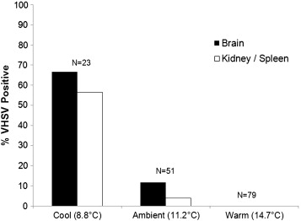

Fig. 3. Effects of temperature on the persistence of VHSV in tissues (brain and kidney/spleen) of survivors 25 d post-exposure. Numerals above the bars (N) represent the total number of survivors at each temperature.

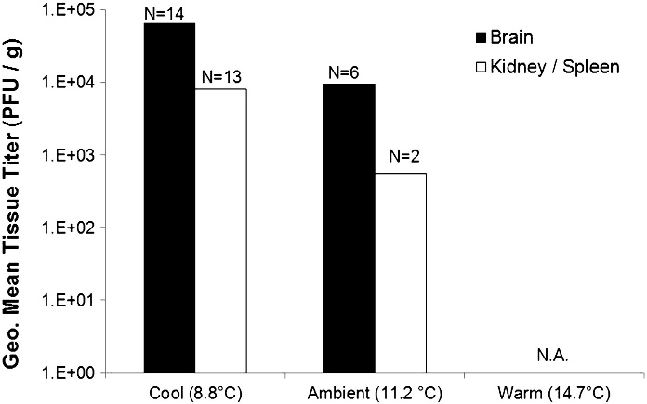

Fig. 4. Effects of temperature on viral load in survivors 25 d post-exposure. Numerals above the bars (N) represent the total number of VHSV-positive fish at each temperature. N.A. (not applicable): none of the tissues from survivors in the warm treatment tested positive for VHSV.

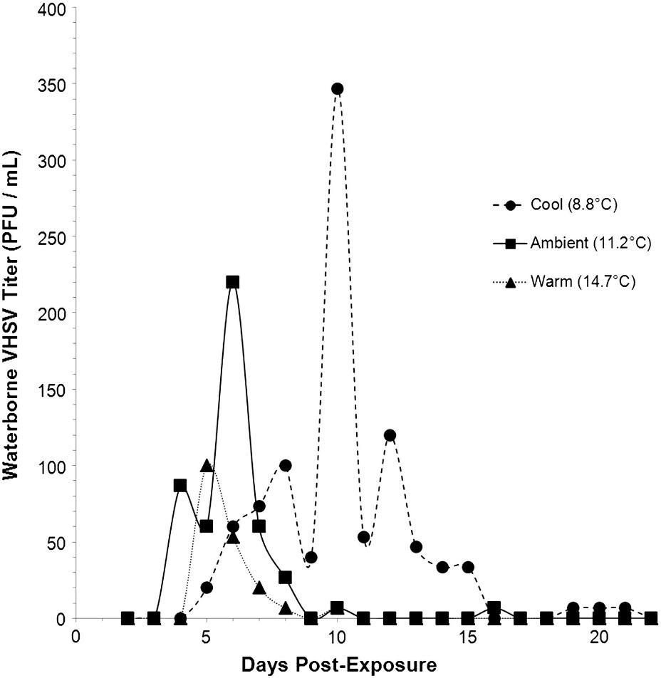

Fig. 5. Effects of temperature on viral shedding from VHSV exposed herring. Data points represent the mean waterborne viral titer in triplicate tanks.

What does this imply for future transmission?

What does this say about ‘recovered’ herring?